RVMS Running Training Schedule:

This week think about beginning a running training program. This will get you ready for all your sports soon. Running is a great cardio or cardiovascular endurance workout. You should remember that this is one of your health-related components of fitness. We just learned about target zone last week, so you need to stay in that zone when you are your walking and running.

I have listed 2 programs for you to choose from. The first one is called “From Running to Walking in 30 days”. This is a beginner or an easy way to start running. It involves walking and running for a certain time.

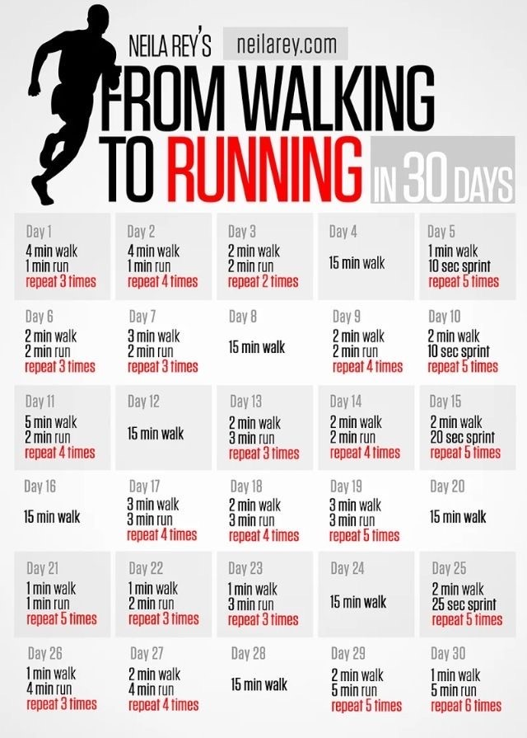
This 5km training plan below is more advanced or difficult. It is 7 weeks long and will take us to the end of the school year. This will help gradually build your cardiovascular endurance week to week and prepare you to complete our annual 5 Km Rave Run. Our Rave Run this year will be a virtual one held on Saturday, June 6th and if you feel your ready you can run during that time OR continue training the rest of June and complete sometime during the week of June 22-26.
You can measure your distance if you have a watch that has a GPS or simply measure the distance you need to run each week with the car’s odometer. Set a goal and challenge yourself to stay fit and active and complete a 5km run…..You Can Do It….Let’s GO!

